PROJECT DOCUMENTATION:SMART PLANT WATERING SYSTEM



SUBMITTED BY:
ABHISEK DAS (1ETMCA20251002)
SUSHREE MOHANTY(1ETMCA20251014)
SUBHASHREE MOHAPATRA(1ETMCA20251021)

ORGANIZATION - FACULTY OF ENGINEERING AND TECHNOLOGY,SRI SRI UNIVERSITY,CUTTACK,ODISHA-754006

EMAIL -
abhisekd.etmca25@srisriuniversity.edu.in
sushreem.etmca25@srisriuniversity.edu.in
subhashreem.etmca25@srisriuniversity.edu.in
Guided by:
Mr. Bisswajeeban Mishra

CONTENTS

- ABSTRACT
- PROJECT OVERVIEW
- SCOPE DEGFINATION
- REQUIREMENTS SUMMARY
- SYSTEM ARCHITECTURE
- DEVELOPMENT PLAN
- TESTING AND QUALITY STRATEGY
- DEPLOYMENT AND OPERATIONS
- RISK MANAGEMENT
- CHANGE MANAGEMENT
- REFERENCES

ABSTRACT

This whole project is based on watering plant without any involvement of human.The main purpose of this project is to solve the negligence of watering small plants and that
manual control of human.As sometimes we forgot to water a plant.This sytstem works by continuously monitoring the soil with the help of sensor.The sensor sends the data to arduino,and then arduino compared the data with the predefined threshold value.After comparison arduino sends the digital value in the form of HIGH or LOW to relay module.Relay module wrok as a switch & it turns on and off the motor according to the measured data.The components that are used ARDUINO UNO R3 , 5V RELAY MODULE , 5V MINI DC MOTOR , SMALL PIPE , POWER BANK .So when soil is dry the motor turns on and when soil is wet motor turns off automatically.

- PROJECT OVERVIEW

- BUISNESS PROBLEM AND MOTIVATION

Manual watering need human efforts and a proper watering schedule.As irregular watering leads to stunting plant growth,water stress and severly damage plant root.
As in traditional method it was mandtory or necessary for constant human efforts for watering a plant and sometimes over watering damged the root even though people can plant water properly but it is mandatory to know how much water a plant need .Sometimes people forget to water the plant and sometimes people over assume that they water the pkant enough but it’s wrong.

So such traditional isssues motivated us to make a project in which the system can plant the water automatically by measuring the moisture of the soil through sensor.The system will continuously monitor the soil moisture levels in real-time,then according to the data it will water the plant in required condition.If soil is dry the system will on the water pump to provide necessary Amount of water & if the soil is wet it will stop the motor automatically.

- OBJECTIVES AND SUCCESS CRITERIA

The primary objective of this project is to eliminate human error in plant care by establishing a smart watering system that ensures efficient water distribution according to the condition.The system monitor the moisture level of soil.Then it checks the threshold cindition.Then it water the plant if soil is dry otherwise it stop the motor.

The project will be consider as success when:
- The capacitive sensor detect soil moisture level.
- Arduino board receive the signal continuosuly and convert that to digital output.
- Relay module working according to the arduino’s given value
- Motor run automatically and stop automatically
- The external power source gives enough power to the motor to run.

- STAKEHOLDERS

The people whoo will be benifited are :

- Plant owneers
- Grden Owners
- Gardener
- Student

- SCOPE DEFINITION

- IN SCOPE:

- Sensing moisture levels
- Processing data through the Arduino controller.
- Moisture level monitoring
- Automated water distribution according to sensor data

- OUT OF SCOPE:

- showing moisture level in an LCD display or mobile application.
- Storing moisture data in cloud databases or external servers.
- Remote control functionality via Wi-Fi or Bluetooth modules.
- Long-term historical data analysis or predictive irrigation modeling.

- ASSUMPTION AND CONSTRAINTS:

ASSUMPTIONS:

- The system need a constant and stable power supply to function reliably throughout the day.
- The sensor is placed coorectly to give accurate readings.
- Powerbank can output stable 5v voltage.
- Relay successfully keep the motor’s power from damaging the microcontroller.

CONSTRAINTS:

The limitations are:
- It is limited by how long powerbank can last.
- Arduino and relay should be out of watering range as they aren’t waterproof.
- Limited watering range.
- One sensor only can monitor a single pot.
- Can’t adapt to weather change.

- REQUIREMENT SUMMARY:

FUNCTIONAL REQUIREMENTS:

- The system must continuously detect soil moisture levels.
- The arduino must receive the analogue signal from sensor ,convert it into digital data, and compare it against the predefined threshold.
- System must trigger the relay to activate the water pump when the moisture level falls below the set limit.
- System must read sensor data in continuos manner.
- The powerbank must supply a continuous 5v output to the motor.

NON-FUNCTIONAL REQUIREMENTS:

- Response time must be of 1-2 seconds.
- The control loop must run without requiremennt of manual reset.
- Relay module must keep the motor’s heavy electrical load isolated from the Arduino to prevent any damage.
- System should be easy to install.
- System should be affordable for common household use.

- SYTEM ARCHITECTURE

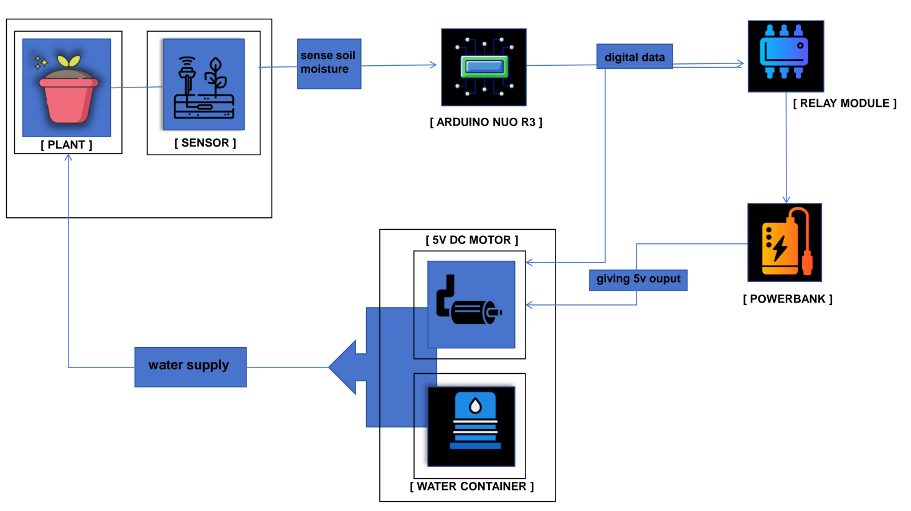

- MAJOR COMPONENTS:

- Arduino Uno R3
- Soil Moisture capacitive Sensor
- 5V Relay Module
- 5V Water Pump
- Jumper wires
- Powerbank of 5v output capacity

- EXTERNAL INTERFACES:

The system works by sensing the moisture level of soil through sensor and sending that value to arduino board.the sensor VCC , GND, A0 connected to arduino’s 3.3V , GND , A0 pins respectively. The relay module’s VCC , GND , Relay IN pins are connected to the Arduino’s 5V, GND, and digital pin 7, respectively.Relay’s COM is connected to power bank’s positive and NO connected to motor’s positive terminal. The negative terminal of the motor is directly connected to the power bank’s negative. This configuration ensures that when the soil moisture drops below the threshold, the Arduino triggers the relay,
The powerbank connected to motor and the relay through a usb cable.

- DEPLOYMENT MODEL

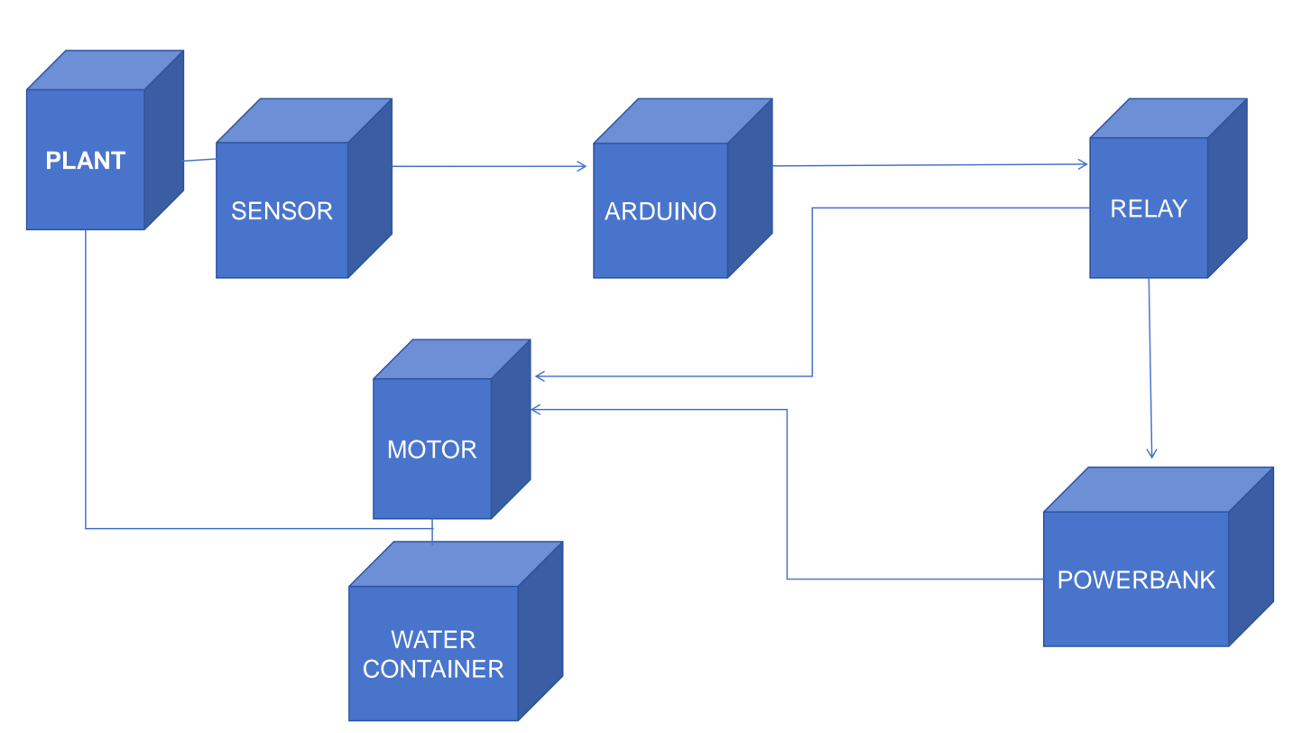

- DEVELOPMENT PLAN

The project undergoes aan implementation srategy.Fist the components were selected Arduino uno r3 board,cpacitive sensor,relay module,5v dc motor,jumper wires,relay module and power bank as external power source for the motor. Then the setup was finalized each component were connoected and placed at suitable place for smooth conduction.Then the code get uploaded to arduino IDE and system undergoes testing as everything is properly co-ordinating or not.

After all these every component worked properly with sync the smart plnt watering system worked successfully.

- TESTING AND QUALITY STRATEGY
The testing phase involved component testing,connectivity check and whole system testing.

- COMPONENT TESTING:

It involves testing each single component like capacitive sensor , arduino board,relay module , DC motor and powerbank . each of these are properly working or not.

- CONNECTIVITY CHECK:

This phase ensured that connection between each component is actually working or not , the data perfectly flowing or not.

- SYSTEM TESTING:

This ensures that at the end the whole system properly
Working or not.

- TESTING APPROACH:

We tested each individual first . forst we connected the sensor with arduino board and checked if the sensor properly wprking or not.After that we connected the powerank to the motor and checked whether the motor working or not.then we connected all the components thriough jumper wire and usb cable then checked as a unit whole system working or not.so basically we followed trial and errror method with manual testing.

- ACCEPTANCE CRITERIA:

- When the soil is wet the reading must be in between 200-400 .
- When the soil is wet reading must be around 450-550.
- Sensor should read moisture level continuously in a loop.
- The moment sensor value>threshold motor should start working automatically as it define dryness.
- After the soil get wet the motor must turnned off between 2 sec interval.

- DEFECT HANDELING:

- If sensor read wrong value do remove that from soil recheck the code and reinstall it inside the soil and make sure there is no gap there in soil .
- If motor stops working do check the wire connection and the battery life of powerbank.
- If sensor is working and value isnt showing do check the budrate and the code.

- DEPLOYMENT AND OPERATIONS:

This project was developed and tested properly before the deployment phase.It was tested in phase by phase and as a unit to ensure it works fluently.

If any issue occurs during the running time of project we simply can disconnect all the hardware comoponents and reassemble them so that it will work [properly.

The sensor continuously monitored the moisture level of the soil and according to this data the relay on and off the motor.

The system is deployed near a plant pot.The sensor is inserted in the pot and connected to arduino through jumper wires.and relay module is connected to the arduino board also with the 5v motor and powerbank of 5v output.
Power is supplied to the motor through powerbank and water supplied through motor.

- RISK MANAGEMENT:

RISK | IMPACT | MITIGATION
Sensor fail | Raed wrong value | Recheck connection or replace sensor
Powerbank discharge | System won’t work | Charge the powerbank
Relay malfunction | Pump may not get trigered | Check connection or replace relay
Motor failure | Water won’t get supply | Replace the motor
Loose wiring | System won’t work | Do proper wiring again

- CHANGE MANAGEMENT:

Changes wrere identified during the testing.

- As during testing the sensor wasn’t reading the values properly so it get reinstalled in the soil propely.
- Motor was triggering continuously even though soil was wet it was still running so the threshold valu rested and aslo wiring was done properly.
- Different code were uploaded and tested to saw which one is suitable.as the motor was getting of after 2 sec and then getting on ,so it was recoded to keep the motor work continuosuly. It will be triggered only when the soil is wet or dry.

- REFRENCES:

- Hackster.io website:-Smart Plant Watering System Using ARDUINO UNO by Neeti Thakur Bisen , April 24 2023 [ https://www.hackster.io/neetithakur/smart-plant-watering-system-using-arduino-uno-47c775 ]
- You Tube-Smart irrigation system by Ktronic110 ,19 april 2024 [ https://youtube.com/shorts/2Y3j4co_lBc?si=T63iTJdAHVPom8cF ]

